Pictures of The Greatest Boom, July 17, 2007, Best Minds Inc.

By Doug Wakefield

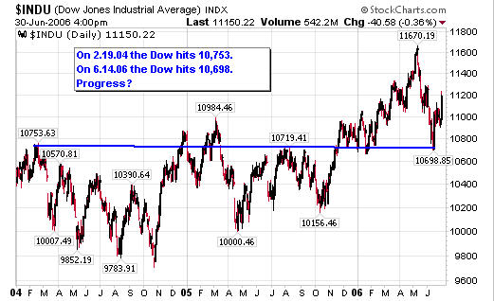

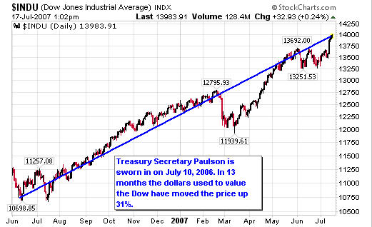

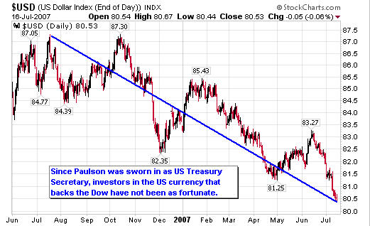

“This is far and away the strongest business economy that I have seen in my lifetime.”

US Treasury Secretary Hank Paulson as stated in “The Greatest Economic Boom Ever”, July 12, 2007, CNN Money

“In the environment of global economic weakness at the beginning of this decade…external demand was declining, and related to that, business investment was declining. We had two alternative ways of sustaining demand and keeping the economy moving forward- one was public spending and the other consumption.

We knew that we had to stimulate consumer spending. We knew we had pushed it up to levels which couldn’t possible be sustained into the medium and long term. But for the time being, if we had not done that, the UK economy would have gone into recession just as the US did.”

The former governor of the Bank of England, Eddie George, as stated in “Ex-Governor Says Bank Deliberately Fuelled Boom”, March 12, 2007. The Independent

Best Minds Inc. prepared this educational piece on July 17, 2007. If you are unfamiliar with our public writings, I would encourage you to google “Doug Wakefield” to find past educational articles on the web. If you are interested in our most in-depth research on various world trends at this time in history, visit our website for a subscription to The Investor’s Mind. A six-month subscription will also give you access to our industry research paper on short selling, “Riders on the Storm.” [Jan.2006].

Doug Wakefield,
President
Best Minds Inc., A Registered Investment Advisor
Best Minds, Inc is a registered investment advisor that looks to the best minds in the world of finance and economics to seek a direction for our clients. To be a true advocate to our clients, we have found it necessary to go well beyond the norms in financial planning today. We are avid readers. In our study of the markets, we research general history, financial and economic history, fundamental and technical analysis, and mass and individual psychology.
Copyright © 2005-2007 Best Minds Inc.

